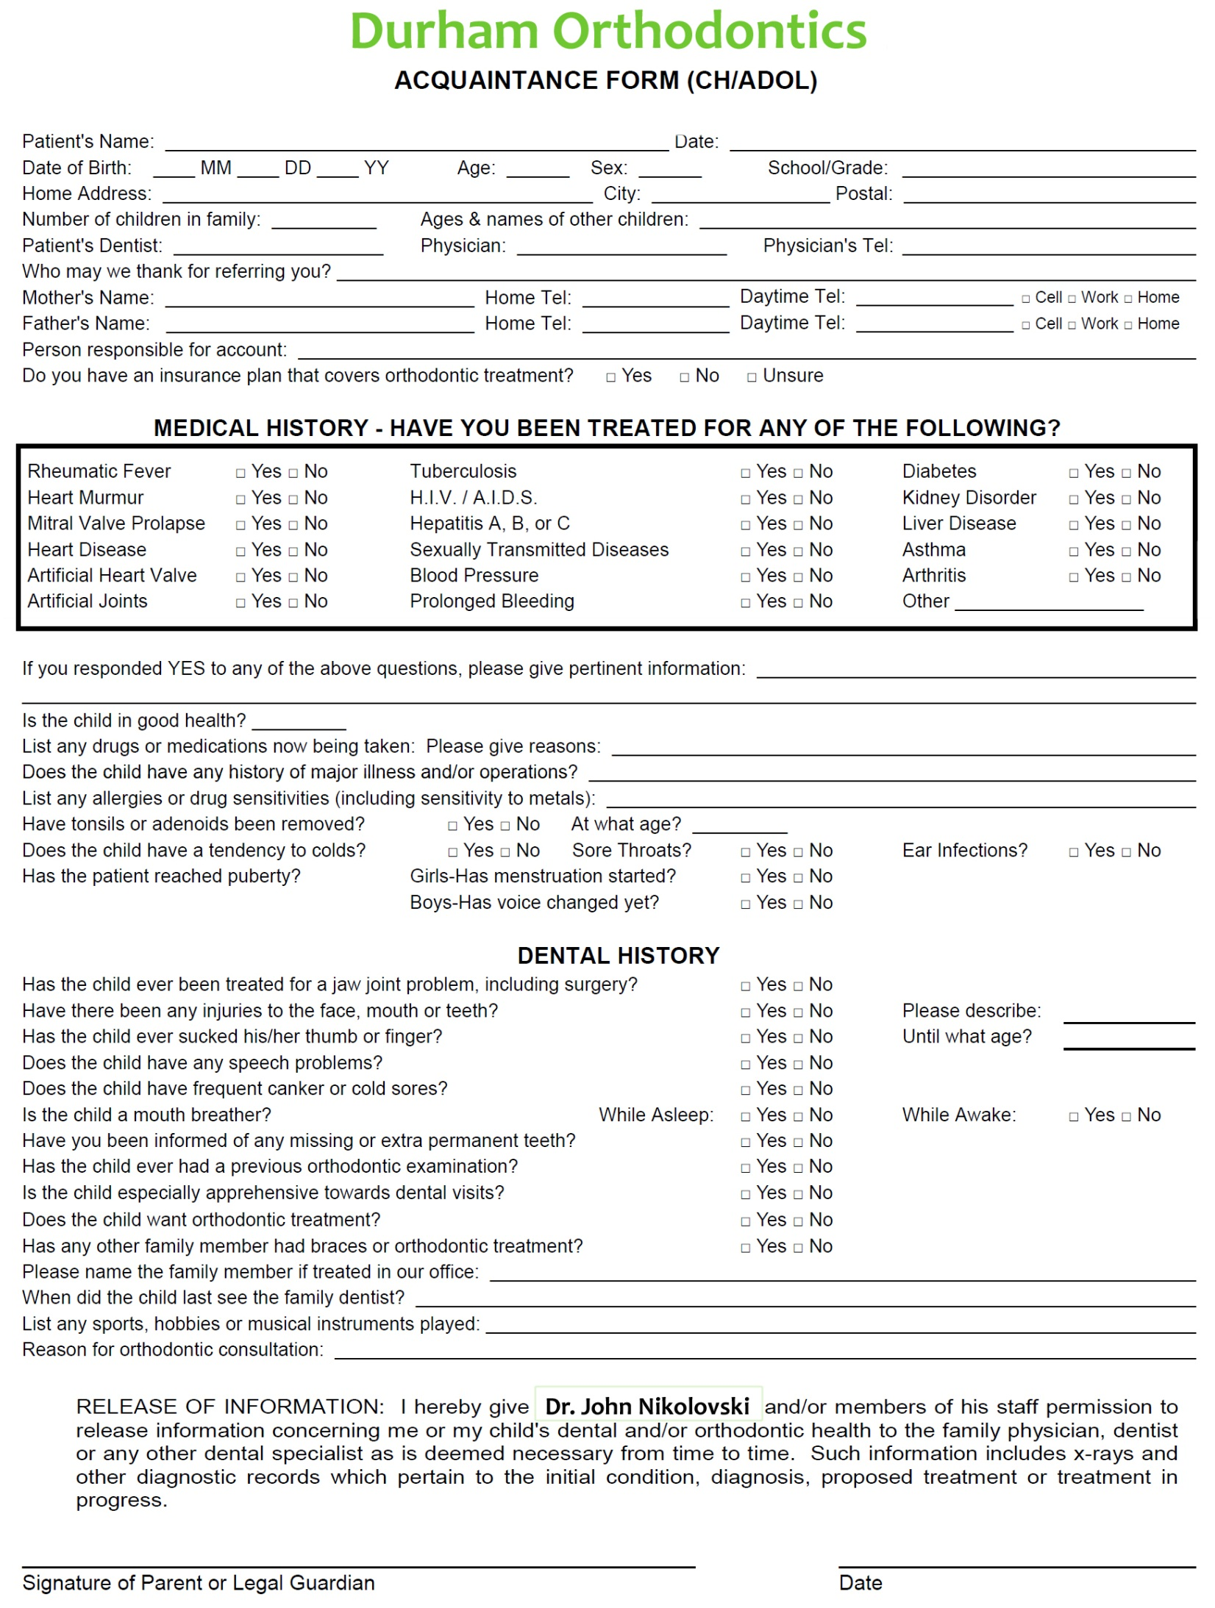
How Our Office Collects, Uses and Discloses Patients’ Personal Information
Our office understands the importance of protecting your personal information. To help you understand how we are doing that, we have outlined here how our office is using and disclosing your information. This office will collect, use and disclose information about you for the following purposes:
- To deliver safe and efficient patient care
- To identify and to ensure continuous high quality service
- To access your health needs, advise you of treatment options and provide health care
- To enable us to contact you and to establish and maintain communication with you
- To offer and provide treatment, care and services in relationship to the oral and maxillofacial complex and dental care generally
- To communicate with laboratories in cases where laboratory services are required
- To allow us to maintain communication and contact with you to distribute healthcare information and to book and confirm appointments
- To allow us to efficiently follow up for treatment, care and billing
- For teaching and demonstrating purposes on an anonymous basis
- To complete and submit dental claims for third party adjudication and payment
- To comply with legal and regulatory requirements, including the delivery of patients’ charts and records to the Royal College of Dental Surgeons of Ontario in a timely fashion, when required, according to the provisions of the Regulated Health Professions Act (RHPA)
- To comply with agreements/undertakings entered into voluntarily by the member with the Royal College of Dental Surgeons of Ontario, including the delivery and/or review of patients’ charts and records to the College in a timely fashion for regulatory and monitoring purposes
- To permit potential purchasers, practice brokers or advisors to conduct an audit in preparation for a practice sale
- To deliver your charts and records to the dentist’s insurance carrier to enable the insurance company to assess liability and qualify damages, if any
- To prepare materials for the Health Professions Appeal and Review Board (HPARB)
- To invoice for goods and services, process credit card payments and collect unpaid accounts
- To assist this office to comply with all regulatory requirements
- To comply generally with the law

Initial: ___________
By signing the consent section of this Patient Consent Form, you have agreed that you have given your informed consent to the collection, use and/or disclosure of your personal information for the purposes that are listed. If a new purpose arises for the use/or disclosure of your personal information, we will seek your approval in advance.
Your information may be accessed by regulatory authorities under the terms of the Regulated Health Professions Act (RHPA) for the purposes of the Royal College of Dental Surgeons in Ontario fulfilling its mandate under the RHPA, and for the defence of a legal issue.
Our office will not under any conditions supply your insurer with your confidential medical history. In the event this kind of request is made, we will forward the information directly to you for review, and for your specific consent.
When unusual requests are received, we will contact you for permission to release such information. We may also advise you if such release is inappropriate.
You may withdraw your consent for use or disclosure of your personal information and we will explain the ramifications of that decision, and the process.
Patient Consent
I have reviewed the above information that explains how your office will use my personal information, and the steps your office is taking to protect my information.
I agree that Dr. John Nikolovski and his staff can collect, use and disclose personal information about _________________________ as set out above in the information about the office’s privacy policies.

_____________________ _____________________
Signature Print Name

_____________________ _____________________
Date Staff Signature (Witness)

